**K2 For SharePoint**

To migrate k2 data to SharePoint online we have multiple options to integrate k2 and SharePoint online such as using custom webservices, use k2 for SharePoint app.

We will go through ‘k2 for SharePoint app’ option:

1. Adding/enabling app into SharePoint site collections

* For testing we have <https://mibagroup.sharepoint.com/sites/DWP> this SharePoint online site.
* Go to site content
* Click on ‘New’ and then ‘App’
* Search ‘k2 for SharePoint’
* To add this app, you have to have ‘owner’ and ‘tenant administrative’ permissions to the site
* Instead of adding app from SharePoint store, try to add it from your site settings only
* You will see below window if you already have an app added to your site, if you don’t have it then ‘Add It’ button will be enabled to add an app

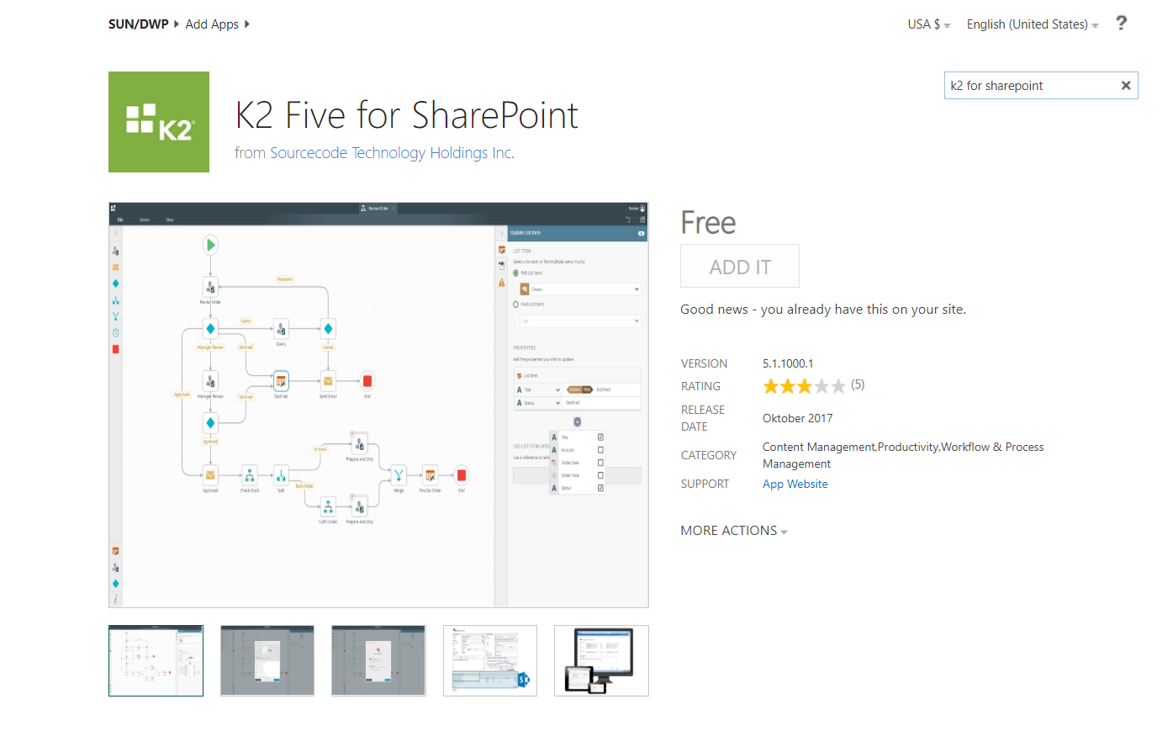

1. Registering k2 app with k2 server (connecting k2 app to k2 server instance)

* Open an app and go to registration vizard page
* To register app, you will get notified to trust your app

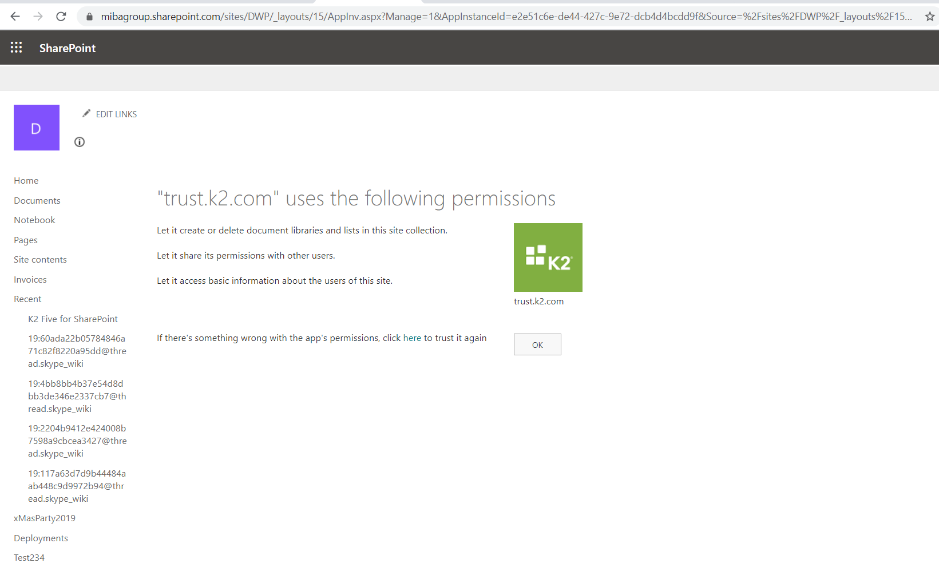

* Specify k2 server url

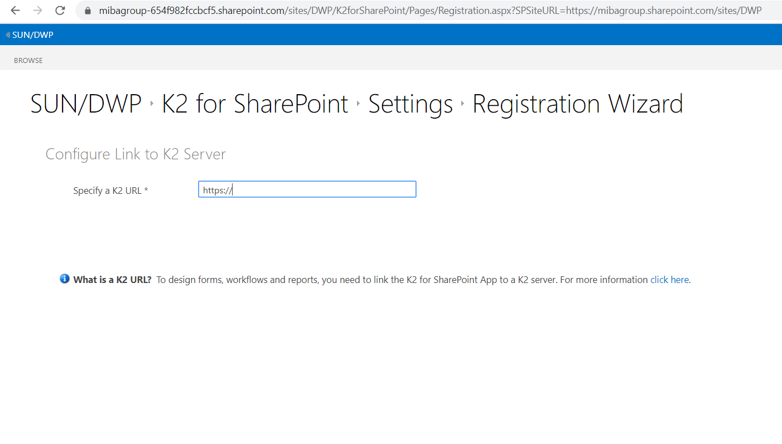

* Run through all the steps to configure app
* If you don’t have admin rights, you will get this window.

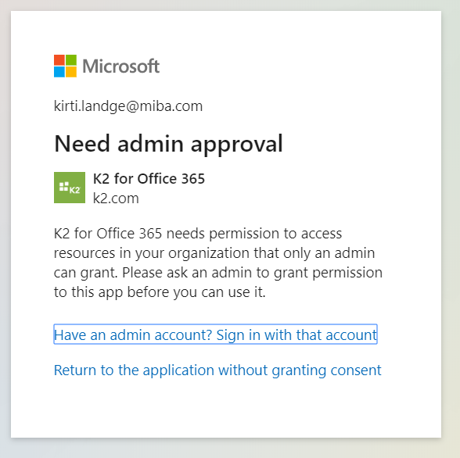

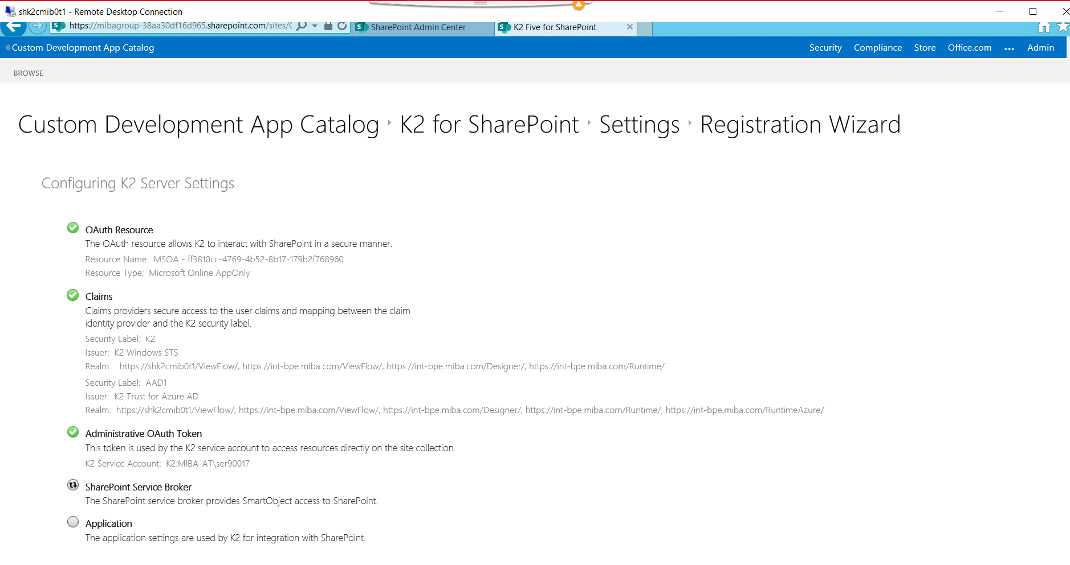

1. Deploy the app
   1. Specify site collection where app will be deployed

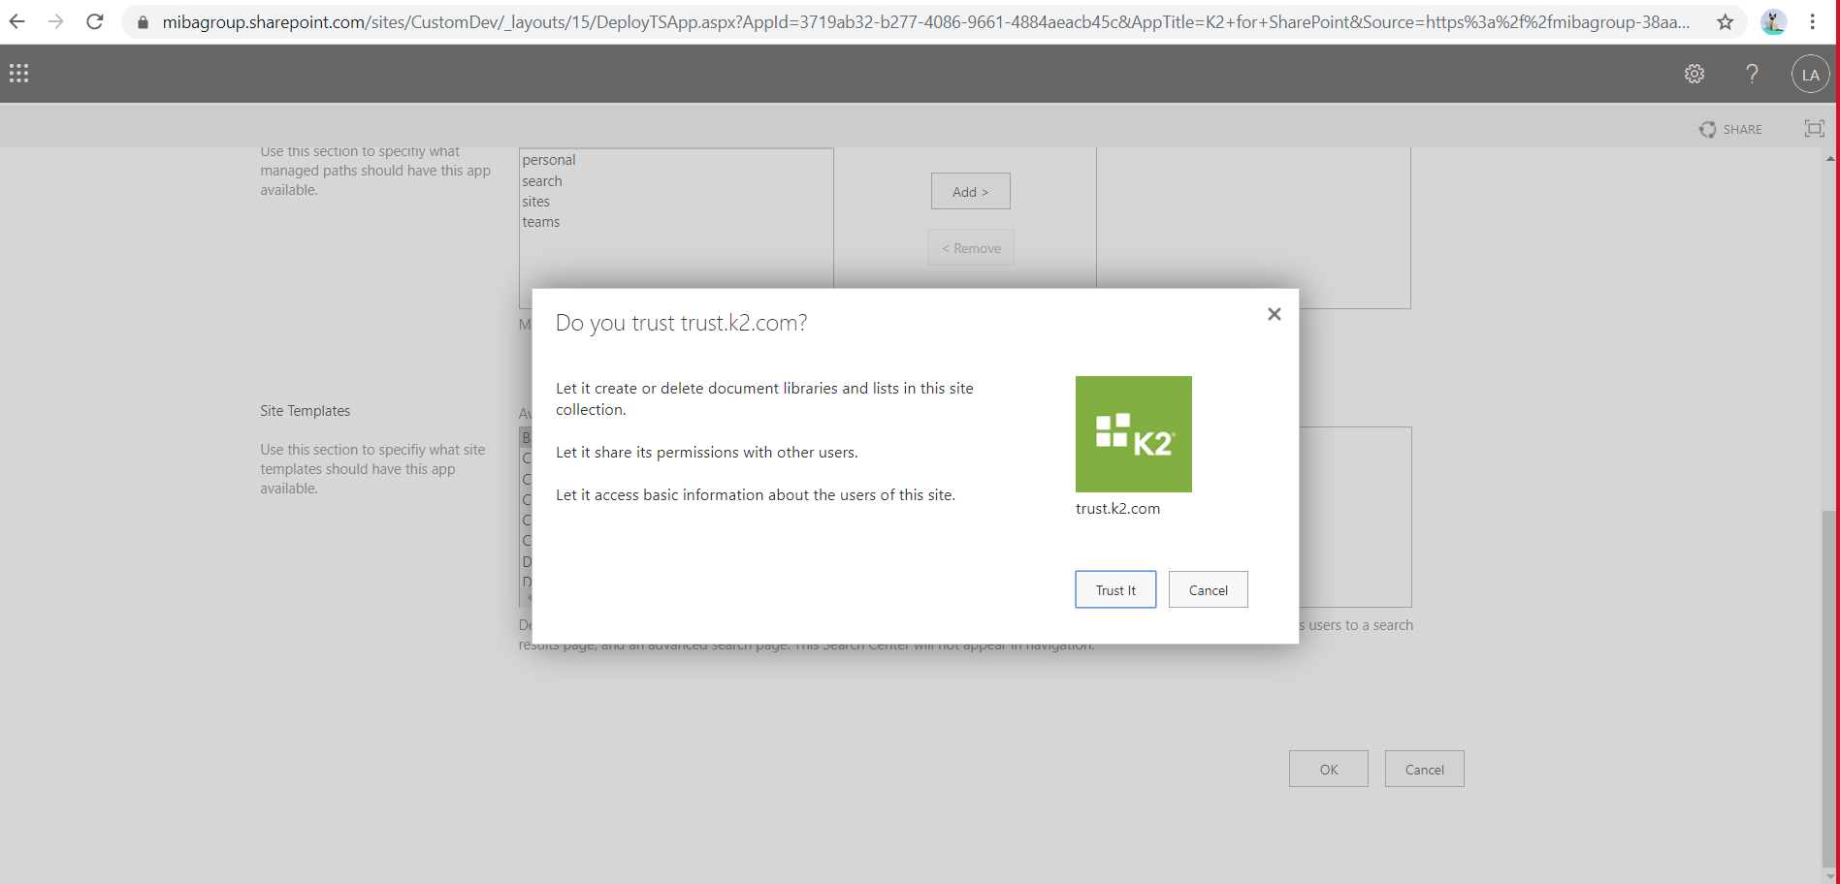

1. Activate the app
   1. Service instance will be created/registered automatically in k2 tester where libraries will be available to access documents/data

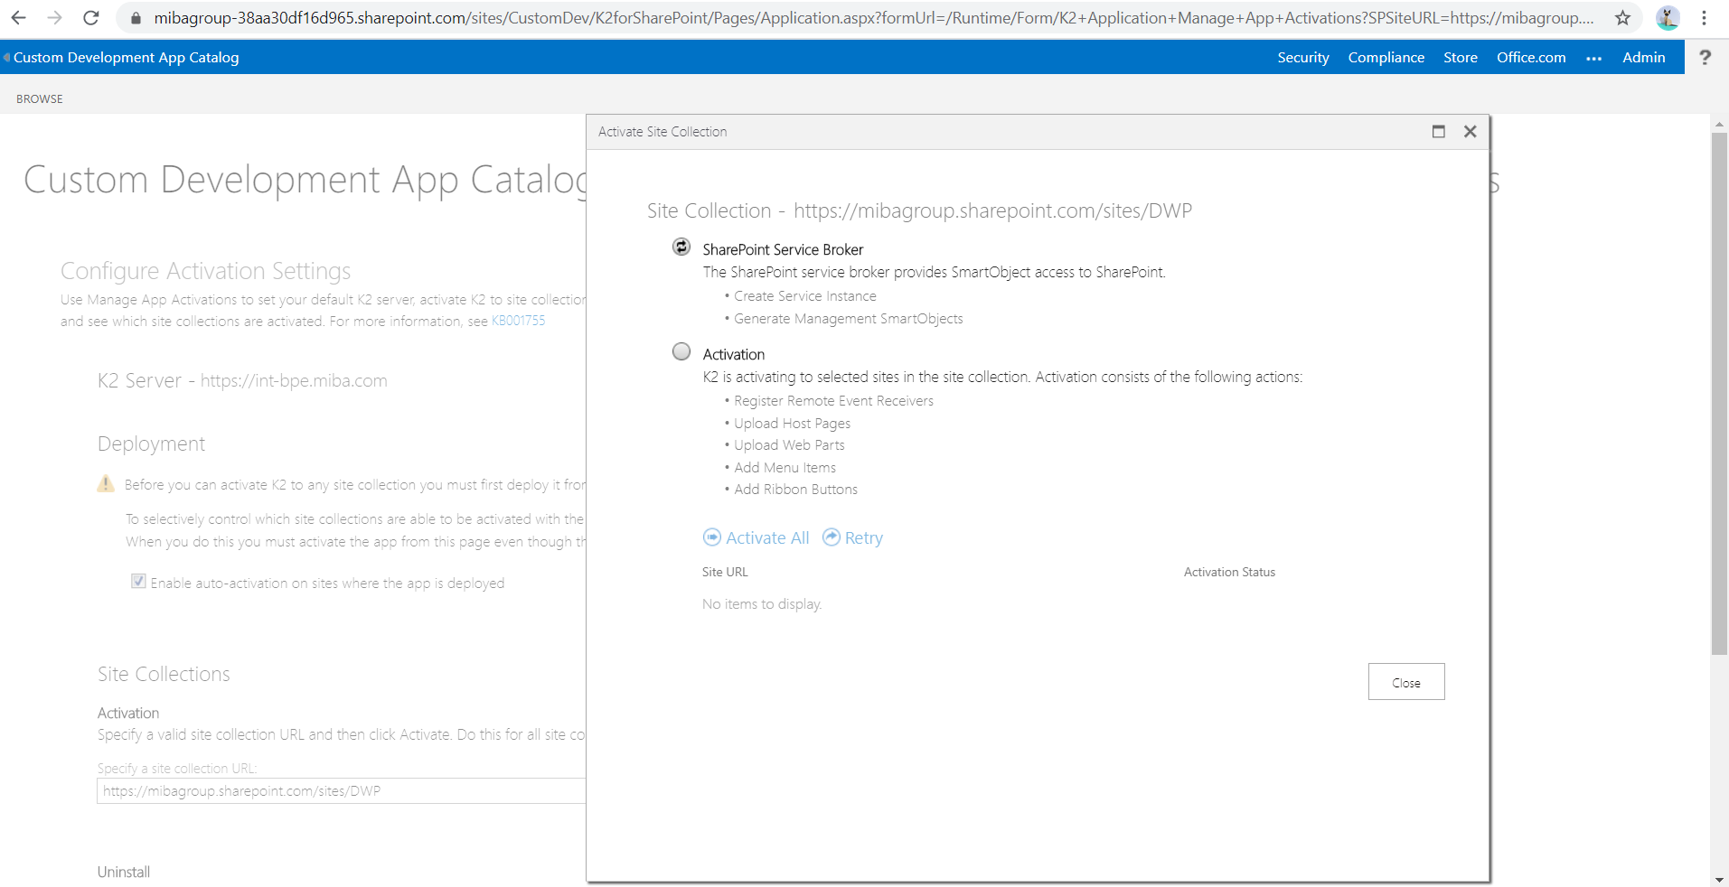

**Testing -**

After activation, service instance will be registered under ‘Sharepoint 2013’ type with name as a site collection url as follow –

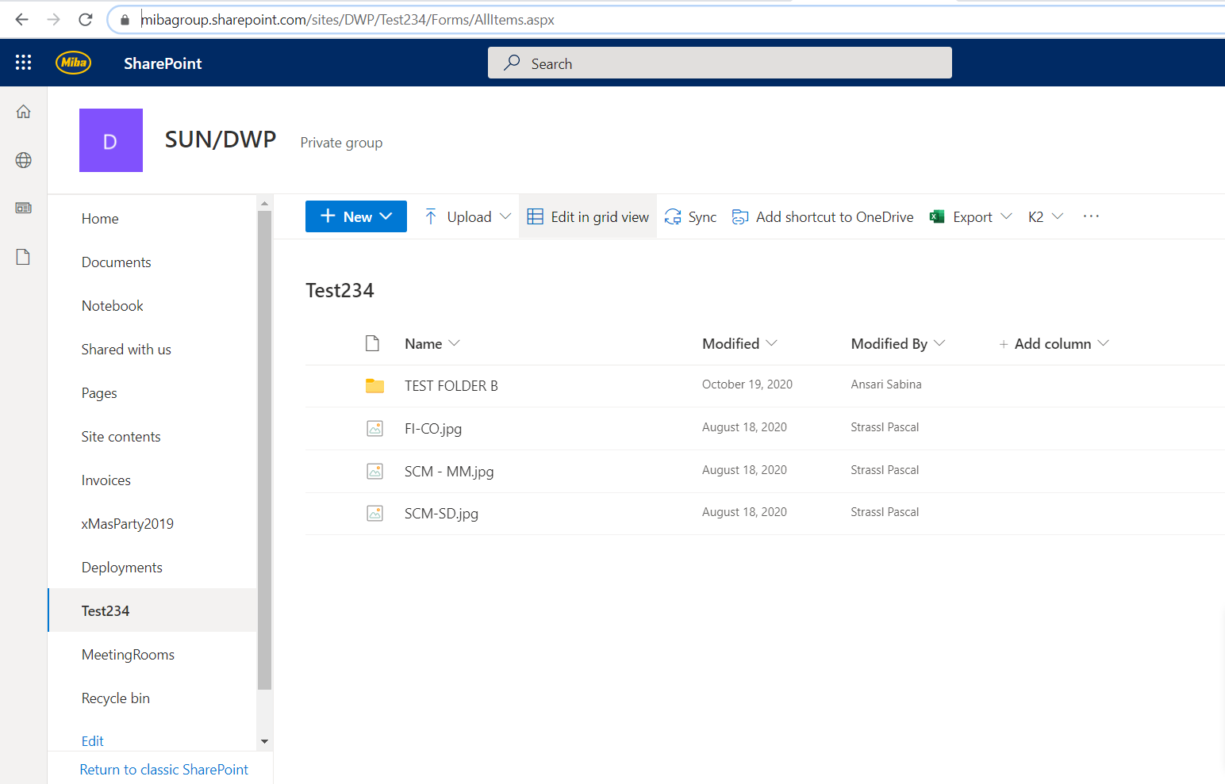

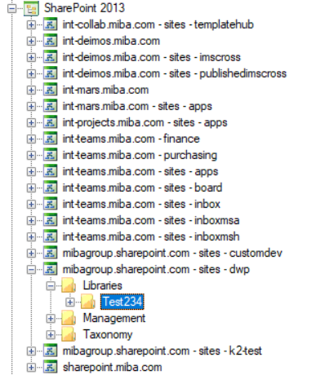

**Create SmartObject –**

Using above service instance, we can create SO of ‘test234’ library to retrieve properties and methods of library

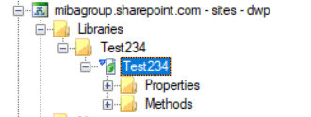

SO will have all the methods to manipulate the list of documents in the library –

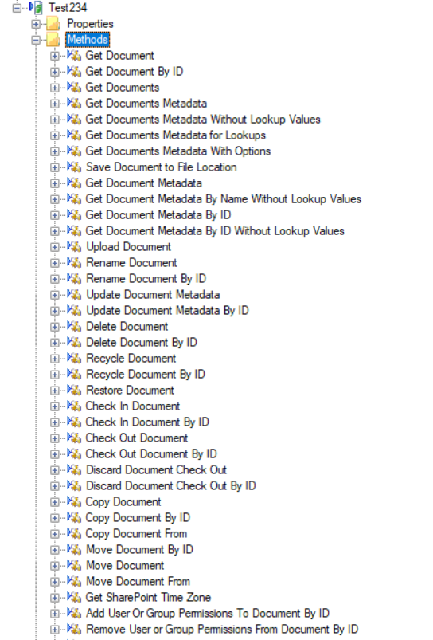 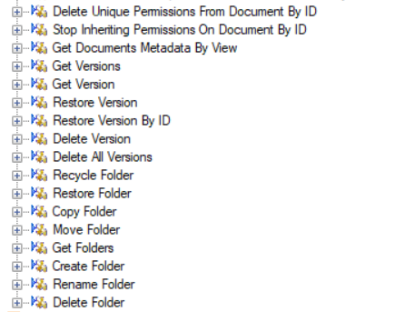

**Execute SO –**

Following are the examples to execute the methods of SO :

